1.Write the program to evaluate the expression 4>3>2, 2+3>4+5 , 6>3+2<5

**Input:**

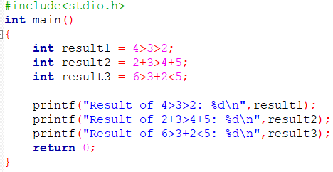

Output:

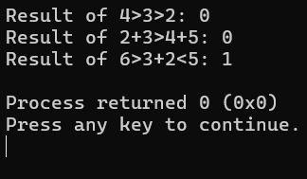

2.Write the program to evaluate the expression 5+3*5>=25%2<=8=5-3*2>=8+3!=5

Input:

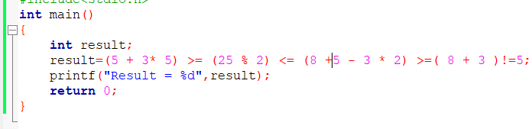Output:

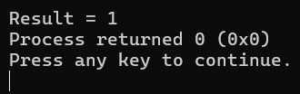

3. Write the program to evaluate the expression 10 && 8 ,0 && 8,0 && 0, 8 && 0.

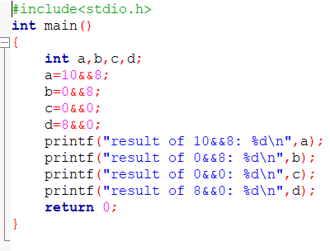

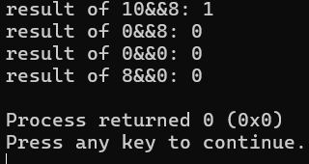

4. Write the program to evaluate the expression ! -8, ! 100 ,! 0,! 0.0

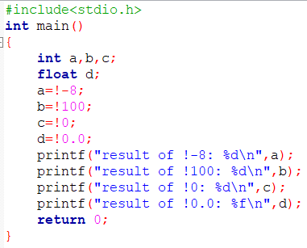

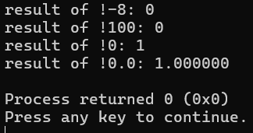

5.Write a program for left shift with 4 shifts <<=4 and right shift with 3 shifts >>=3.

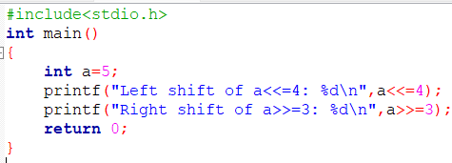

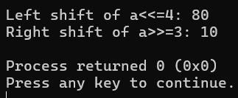

6. Write the program to evaluate the expression

4 > 5 , 4 < 5, 4 >= 5, 5 = 5, 4 == 5,

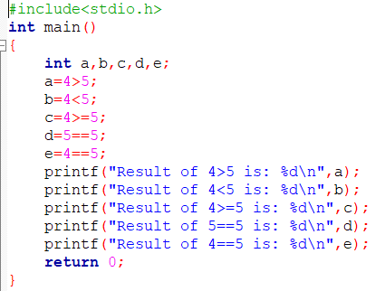

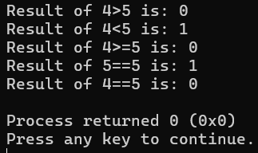

7. Write the program to evaluate the expression 4>3 && 3>2

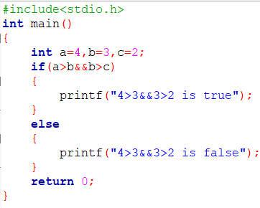

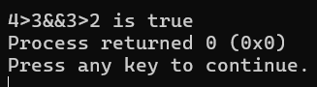

8. Write the program to evaluate the expression !!!!a

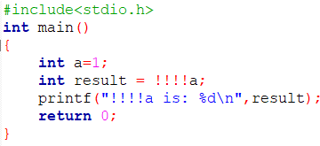

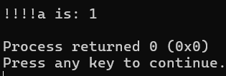

9.How many tokens in the given program and what are the tokens.

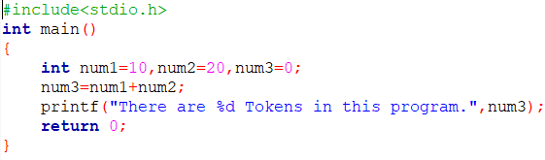

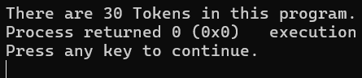

10.Write a program to divide two numbers without using / operator.

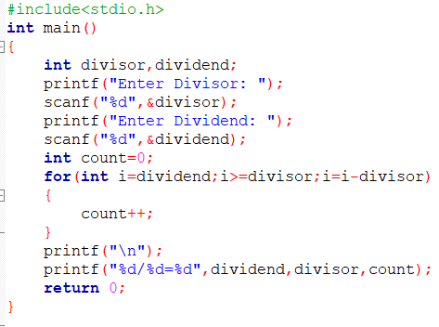

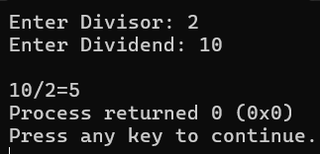

**Application 6:**

Write the c program for library management,get input for different category of books and no of books in each category and calculate the total books

Input:

